**Installation of solder-free connector with plug)**

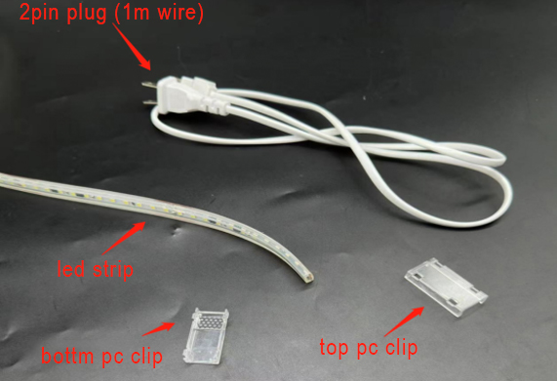

**Step 3:**  
Put the clear PC clip on the bottom

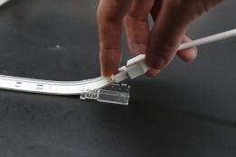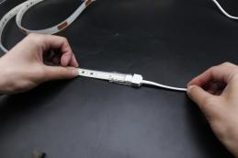

**Step 2:**  
Insert the 2pin plug in to the led strip, pls makes sure the connector plug on the back of the pcb soldering pad

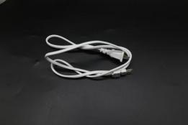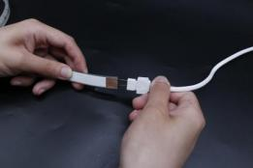

**Step 1:**  
Cutting the led strip as the minimum cutting unit(every 12leds per cut)

Remark (the back of the led strip light have the cutting mark)

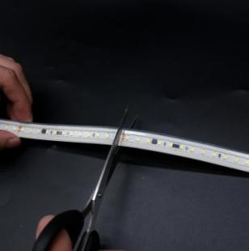

**Step 6:**

Let it stand for 15-20 minutes before moving it，turn on the power to light up the strip,

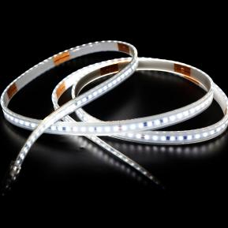

**Step 5:**

Put the top transparent PC clip insert to the bottom PC clip

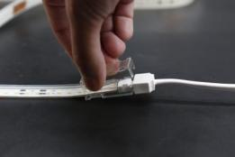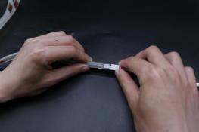

**Step 4:**

Using the glue to fill up the gap, make sure there no empty space in the clip

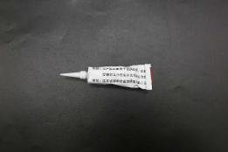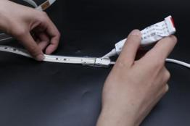

**Installation of the strip to strip solder-free connector**

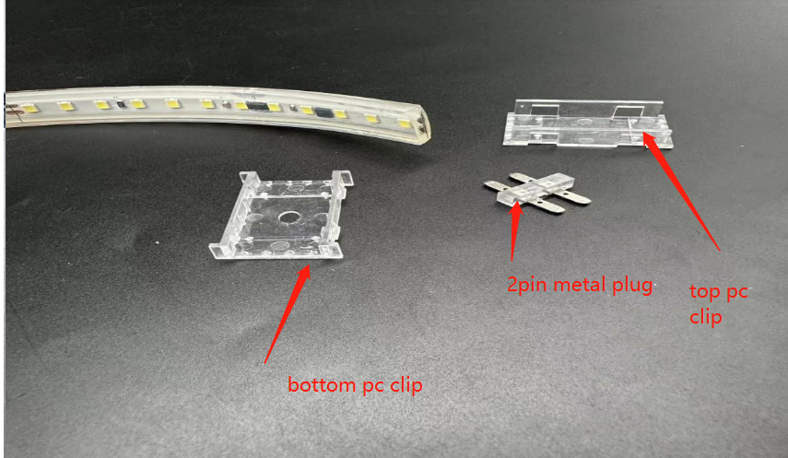

**Step 1:**  
Insert the 2pin metal plug into the strip,pls makes sure the 2pin metal plug insert on the back of the pcb soldering pad

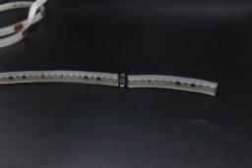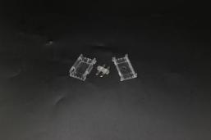

**Step 2:**  
Put the transparent PC clip on the bottom

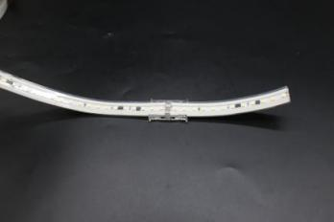

**Step 3:**  
Put the top transparent PC clip insert to the bottom PC clip.

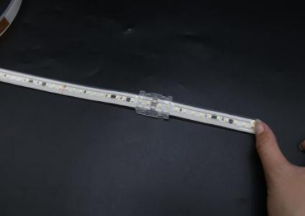

**Step 5:**

Let it stand for 15-20 minutes before moving it,turn on the power to light up the strip,

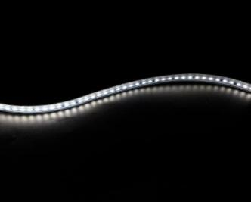

**Step 4:**

Inject the glue through the hole on the bottom, make sure there no empty space

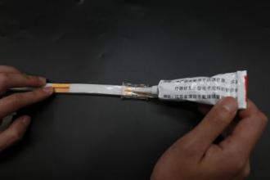

**Installation of the silicone end cap**

**Step 1:**  
Inject the glue around the end of strip.

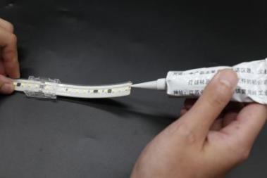

**Step 2:**  
Inject the glue to the end cap

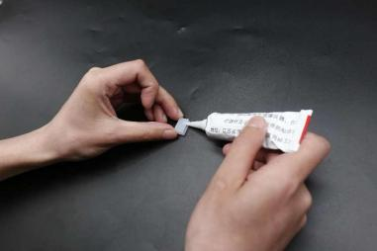

**Step 3:**  
Insert the strip into the end cap

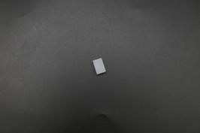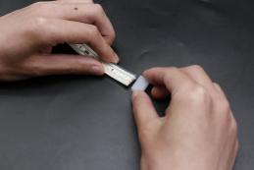

**Step 4:**  
After install the end cap, let it stand for 15-20 minutes before moving it

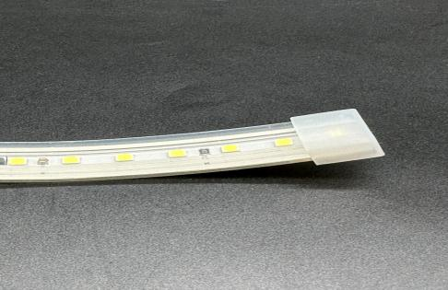

**Installation of the LED Strip**

**Method 2:** Install by the plastic clip

Fix the strip on the installation position with the plastic clip and screw

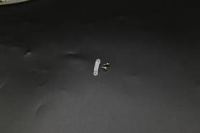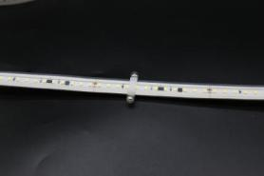

**Method 1:** Install by the 3M tape

Remove the 3M tape on the back of led strip and attach the strip to the installation position

